GATEWAY LOAD BALANCER

What is Gateway Load Balancer
Gateway Load Balancer is an AWS service that allows you to insert security appliances into the network path and automatically distribute traffic to them.

Think of it as a security checkpoint.
Application Traffic
↓
Gateway Load Balancer
↓
Firewall / IDS / IPS
↓
Destination

Why do we use Gateway Load Balancer?
Normally traffic goes directly:
EC2 --------> Internet
With GWLB:
EC2 -----> GWLB -----> Firewall -----> Internet
Now every packet can be:
- Inspected
- Filtered
- Logged
- Monitored
before reaching its destination.

Where is GWLB used?
GWLB is commonly used with:
- Palo Alto Firewall
- Fortinet Firewall
- Check Point Firewall
- IDS (Intrusion Detection System)
- IPS (Intrusion Prevention System)
- Deep Packet Inspection Appliances
Company VPC
↓
GWLB
↓
Palo Alto Firewall
↓
Internet

What can a Security Appliance do?
- Block Malicious Traffic
Hacker -------> Firewall (Blocked)
- Allow Only Required Ports
- Allow: 80 (HTTP) / 443 (HTTPS)
- Block: 21 (FTP) / 23 (Telnet)
- Detect Attacks
DDoS Attack -------> Security Appliance -------> Detect & Alert
- Log All Traffi
- Who connected?
- Which IP?
- Which port?
- What time?
- Inspect Packets
Security appliances can inspect packet contents and identify:
- Malware
- Viruses
- Suspicious traffic
- Unauthorized access attempts

Why GWLB + Security Appliance?
Imagine a company has:
10 Application VPCs
Instead of installing a firewall in every VPC:
VPC-1 ─┐
VPC-2 ─┼──► GWLB ─► Firewall
VPC-3 ─┘
One centralized security layer protects all VPCs.

Security appliances are used to inspect, filter, monitor, and secure network traffic. They help block malicious requests, enforce security policies, detect attacks, and log network activity. Gateway Load Balancer is used to transparently route traffic through these security appliances for centralized inspection.

PRACTICAL ON GATEWAY LOAD BALANCER
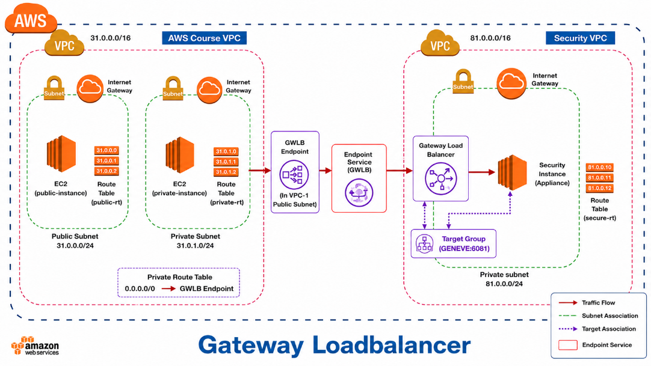
AWS-Course-VPC
- create a vpc (AWS-Course-VPC) (31.0.0.0/16)
- create a subnet
- aws-course-public-subnet-1 (31.0.0.0/24)
- aws-course-private-subnet-2 (31.0.1.0/24)
- create a internet gateway and attach to AWS-Course-VPC
- create a route table
- aws-course-public-route-table
- route ------ internet gateway
- subnet ---- aws-course-public-subnet-1
- aws-course-private-route-table
- subnet ---- aws-course-private-subnet-2
- create a instance
- name ----- public-instance
- type ------- t3. micro
- ami -------- amazon linux
- vpc -------- AWS-Course-VPC
- subnet --- aws-course-public-subnet-1
- sg --------- ssh/http/ICMP
- enable --- auto assign public ip
- create instance
- create a instance
- name ----- private-instance
- type ------ t3. micro
- ami ------- amazon linux
- vpc -------- AWS-Course-VPC
- subnet --- aws-course-private-subnet-2
- sg --------- ssh/http/ICMP
- create instance

Security-VPC
- create a vpc (Security-VPC) (81.0.0.0/16)
- create a subnet
- security-private-subnet (81.0.0.0/24)
- create a internet gateway and attach to Security-VPC
- create a route table
- security-route-table
- route ------ internet gateway
- subnet ---- security-private-subnet
- create a instance
- name ----- security-instance
- type ------ t3. micro
- ami ------- amazon linux
- vpc ------- Security-VPC
- subnet -- security-private-subnet
- enable --- auto assign public ip
- security-group
- ssh (MyIP)
- All Traffic ------- AWS-Course-VPC CIDR (31.0.0.0/16)
- create instance
- Access the instance
- sudo yum install tcpdump -y

- create a target group
- name ----- security-target-group
- vpc -------- Security-VPC
- protocol - GENEVE
- port ------ 6081
- register - security-instance
- create target group
- create a gateway load balancer
  - type ------- gateway load balancer
  - name ----- security-gwlb
  - vpc -------- Security-VPC
  - target ---- security-target-group
  - create load balancer

- create endpoint service
- name ----- gwlb-endpoint-service
- lb type --- gateway load balancer
- lb --------- security-gwlb
- disable -- acceptance required
- create endpoint service

- create a vpc endpoint
- name ----- aws-course-endpoint
- type ------ endpoint services that use NLBs and GWLBs
- service name ---- paste endpoint-service name
- verify service
- vpc -------- AWS-Course-VPC
- subnet --- aws-course-public-subnet-1
- create endpoint

- update private route table of aws-course-vpc
- route table ---- aws-course-private-route-table
- edit routes
- destination ---- 0.0.0.0/0
- target --------- gateway load balancer endpoint
- save changes

Verify
- login to security-instance
- run command
sudo tcpdump -nvv port 6081
- login to private-instance of aws-course-vpc
- generate traffic
ping 8.8.8.8
OR
curl google.com
- switch back to security-instance
- verify GENEVE traffic on port 6081

TRAFFIC FLOW OF INSTANCE

private-instance
↓
GWLB Endpoint
↓
Endpoint Service
↓
Gateway Load Balancer
↓
Target Group (GENEVE:6081)
↓
security-instance

WHY WE ATTACH AN INTERNET GATEWAY IN SECURITY-VPC?
1. In this practical, the Internet Gateway is attached to Security-VPC only for management purposes. It allows us to assign a public IP to the security-instance, connect through SSH, and install tools such as tcpdump for traffic verification.
2. Gateway Load Balancer does not require an Internet Gateway to function. In production environments, the security-instance is usually deployed in a private subnet and accessed through a Bastion Host, VPN, or AWS Systems Manager.

